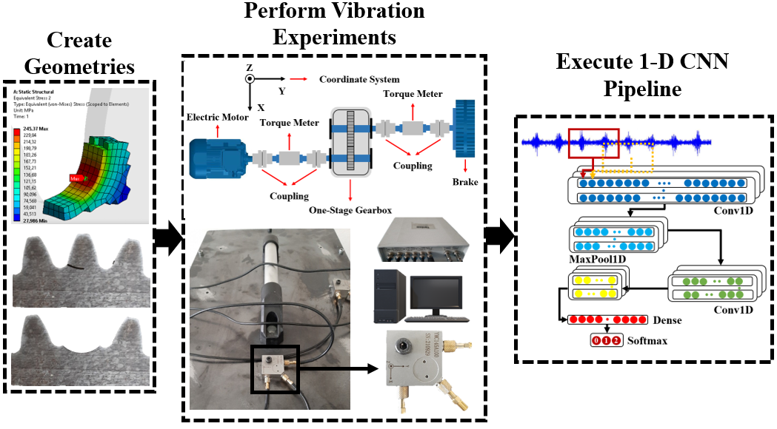

**Publication title:**

Gearbox fault diagnosis with deep learning under variable operating conditions

**Authors:**

Onur Can Kalay, Fatih Karpat, Esin Karpat, Ahmet Emir Dirik, Stephen Ekwaro-Osire.

**Links:** https://doi.org/10.1115/IMECE2024-144598

**Abstract:**

The gearboxes are indispensable universal components to transfer power and handle precision functionalities in modern industry. Their health management is also essential to minimize workforce risks, increase the level of safety, and avoid machine breakdowns. From this standpoint, the present experimental research work developed a convolutional neural network-based method for diagnosing different levels of tooth root cracks (50%-100%) for spur gears. A series of vibration experiments were performed on a single-stage spur gearbox by employing tri-axial accelerometers under variable working conditions. The effects of different levels of tooth cracks on vibration amplitudes were also investigated within experiments. To address the impact of sensor location on the vibration responses of healthy and cracked spur gear pairs comparatively, a total of three sensor locations were determined and tested in the research work. Within the vibration experiments, the impact of two shaft speeds (300 rpm-600 rpm), three loading conditions (zero-load, 10%, and 20%), and three measurement axes (x, y, and z) on the vibrational amplitudes and fault recognition accuracy were evaluated. The findings showed that the proposed convolutional neural network model classified different root crack levels under variable operating conditions between the overall accuracies of 95.015% and 99.970%.